The difference between mass and weight

For a lot of people, it’s very difficult to understand the difference between mass and weight.
More and more pupils, in vocation school, think that Americans have never walked on the moon.
That why, I tried to make a lesson which lets work this two points.

We saw a part of video of the Apollo 17 mission and we analyzed it with a kinematic software.
I used a video found on YouTube and I made a montage. This video can be downloaded here.

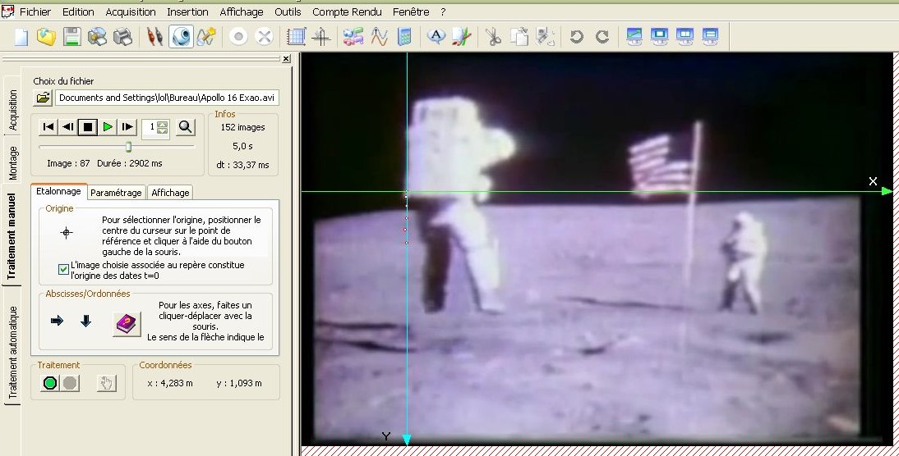

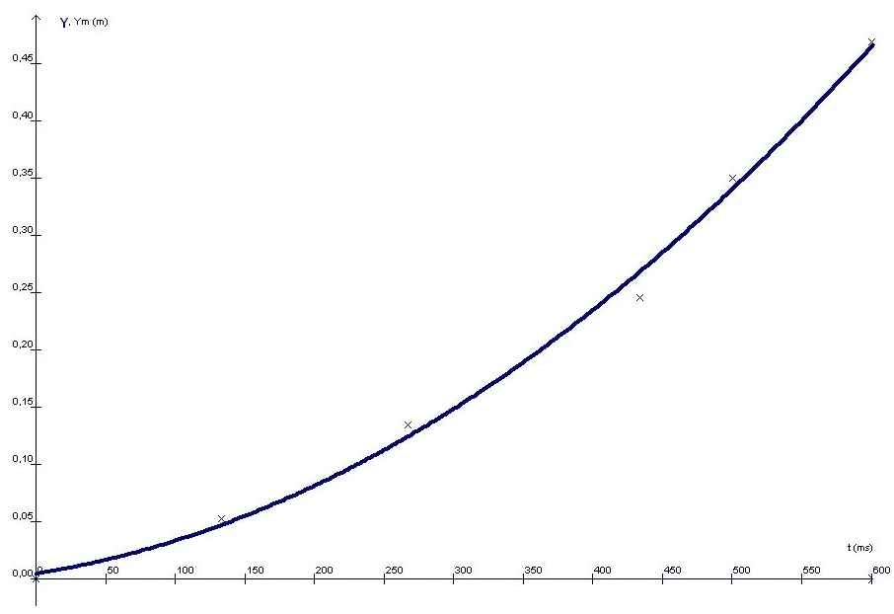
Study of a falling object on the moon

$$y= \frac{1}{2} a t^{2}+b t+c$$

$$a=1,91$$
$$b=192× {10}^{-3}$$
$$c=4,43 ×{10}^{-3}$$

Conclusion:

The movements of astronauts are strange. On Earth, we can’t move as well. In addition, astronauts jumped up to 46 cm with a combination of 110 kg. Tests done in class gave us about 10 cm. Pupils must jump the same way as on the video.
The calculation of gravity on the moon gives us 1.9 m/s² , which is near the theoretical value, even if this video quality is very bad.
It would be better to work with the history teacher to study the history of space conquest.

